# Club Membership Planner Application B3

## Main Menu

## Add Member:

## Membership Report

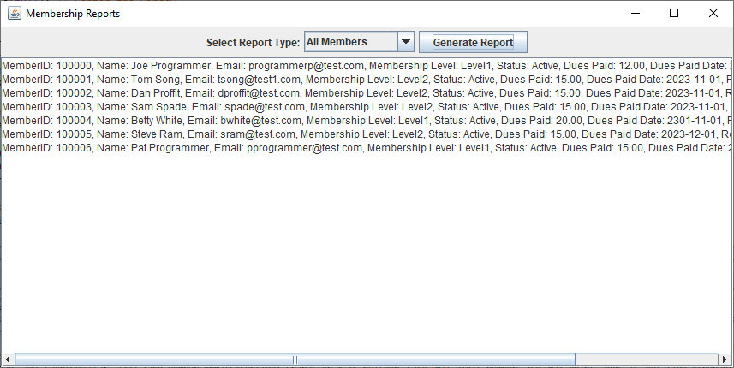

## Update Member:

## Delete Member:

